Wandsworth Tobacco Control Alliance
Annual Report 2011-2012


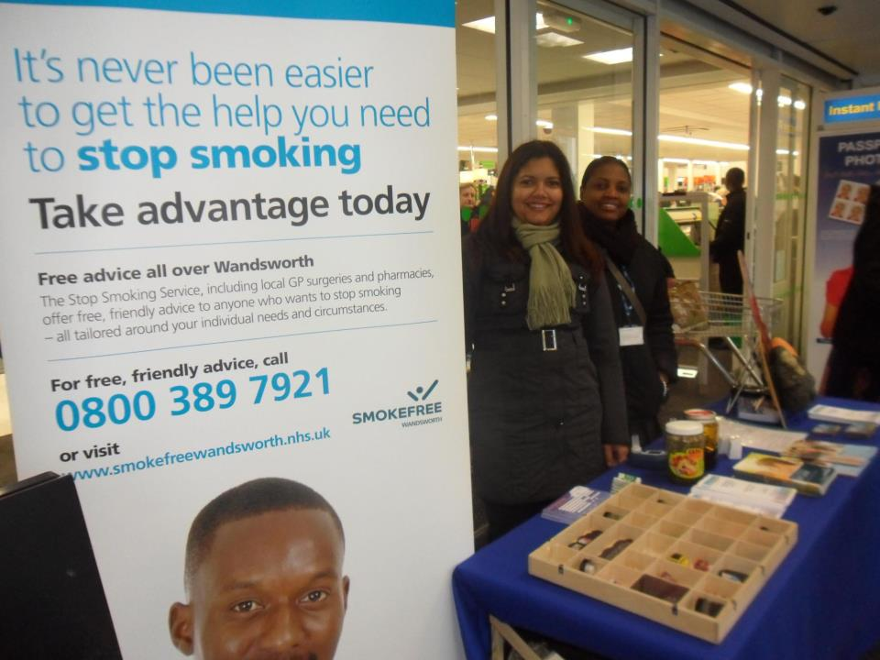


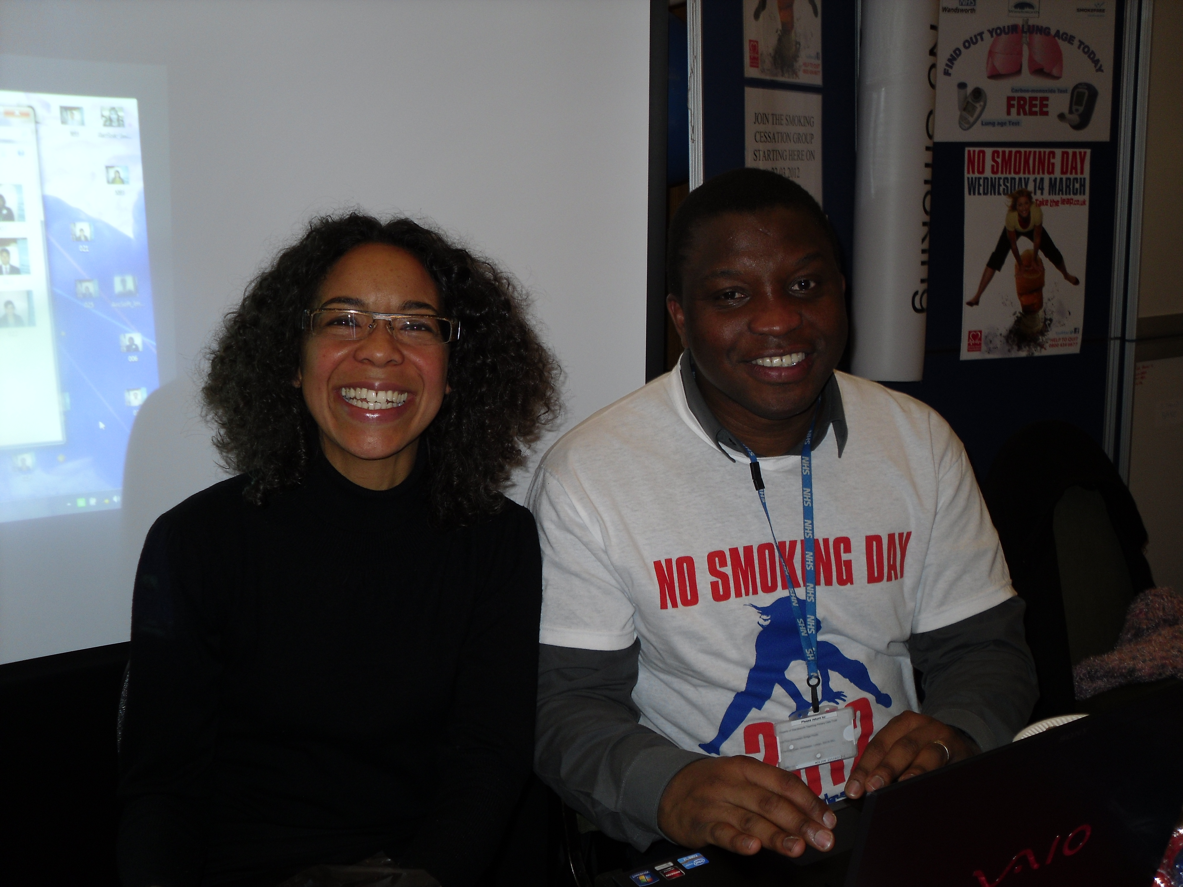

Working with local partners in the community to reduce tobacco consumption

Wandsworth Tobacco Control Alliance
Annual Report 2011-2012

Contents
Coordinator’s Statement Page 3

Introduction Page 3
Progress on actions 2011-2012 Page 4

General Page 4

Priority 1. Implementing enforcing legislation to control the sale and use of tobacco Page 5
Priority 2. Promoting a ‘smoke free homes’ initiative Page 6
Priority 3. Preventing the uptake of smoking by young people Page 7
Priority 4. Increasing uptake of smoking cessation services Page 8
Priority 5. Delivering a communications plan to support the strategy Page 10
Appendix 1:
Membership of the Wandsworth Tobacco Control Alliance and Terms of Reference Page 12
Glossary
WTCA Wandsworth Tobacco Control Alliance
SSS Stop Smoking Service
NHS National Health Service
TS Trading Standards
PHSE Personal, Social and Health Education
NCSCT National Centre for Smoking Cessation Training
OSS Operation Smokestorm
GPSI General Practitioner Specialist Interest (smoking)
PRU Pupil Referral Unit
CC Children’s Centre’s
LBW London Borough of Wandsworth
GP General Practitioner
SFH Smokefree Homes
LES Local Enhanced Services

References
Healthy Lives Healthy People National Plan on Tobacco Control Targets 2011 DH.
Coordinator’s Statement

Welcome to the first Annual Report of Wandsworth Tobacco Control Alliance, WTCA. The WTCA is a body that brings together key partners and organisations to work towards reducing tobacco consumption in Wandsworth. This annual report shows the highlights of the activity generated to date and the outcomes achieved since the alliances establishment back in October 2011.

Introduction
Smoking remains the most significant single cause of premature mortality in Britain, and is by far the biggest single direct contributor to differences in life expectancy between more and less affluent communities. In 2010 the Tobacco Control National Support Team visited Wandsworth to review the work being undertaken to reduce smoking prevalence in Wandsworth. Whilst much of the advice provided by the support team was around the functioning of the NHS Stop Smoking Service, a key recommendation was that NHS Wandsworth and Wandsworth Borough Council should come together, with other relevant parties, in a Tobacco Control Alliance with an agreed strategy to reduce smoking prevalence.

National Guidance
The Coalition Government’s plan for reducing tobacco smoking prevalence in England was published in March 2011. This presented the role of local tobacco control alliances as central to reducing smoking prevalence, emphasised the role of local authorities in leading these alliances, and set out suggested areas of work.

Wandsworth Tobacco Control Strategy
The Wandsworth Tobacco Control Strategy has been developed in partnership with key agencies that came together as an alliance to ensure delivery of the strategy. The aim is to achieve a 3% reduction in smoking prevalence in Wandsworth by 2015.
The overall objectives of tobacco control in Wandsworth are:
- to reduce the negative impact of tobacco use on the lives of the people in the borough;
- and by reducing tobacco use, reduce health inequality in the borough;
- by reducing tobacco use, deliver savings of nearly £11million per annum to the local economy.
The Alliance has developed and implemented annual action plans to address the five priority work areas identified in the strategy, these are:
- implementing and enforcing the legislation to control tobacco sales;
- promoting a ‘smoke free homes’ initiative, encouraging those people who do smoke to smoke outside, thereby reducing the impact of passive smoking and risk of accidental fires;
- preventing the uptake of smoking by young people;
- increasing the impact of smoking cessation services; and
- delivering a communications plan to support the strategy.
Each priority area has a lead officer to take forward the action plan and progress is reported to the alliance quarterly. The coordinator provides support and guidance to each lead throughout the project delivery.

Progress on Actions 2011-2012

General

At the February 2012 WTCA meeting the alliance agreed the following:

- Terms of Reference *

- Accountability to the Health and Well Being Board

Influencing Regional, National Policy and legislation throughout the year:

- Attendance at the London Regional Tobacco Control Network
- Responded to government consultation on Plain packaging for tobacco products
- Responded to Age Restricted Products and Services, A Code of Practice for Regulatory Delivery, Better Regulation Delivery Office
- Letter sent to Minister about the loop hole in the law around Proxy Sales of Tobacco
* Appendix 1 Terms of Reference and Membership of the WTC Alliance

P1. Implementing and enforcing legislation to control the sale and use of tobacco

Trading standards (TS) have responsibility for ensuring compliance and enforcement of legislation relating to tobacco control and underage sales. Illicit tobacco continues to undermine recent efforts to reduce consumption with policies that use tax to maintain the high price of tobacco products. Working in partnership with TS ensures we identify and deal with this issue in the borough. It was a busy time with new regulations in October 2011 for the removal of cigarette vending machines from pubs and clubs and the end of point of sale displays in all shops over 280 square metres in April 2012 and small retailers by 2015.

Progress

Trading Standards received additional funding from NHS Wandsworth to enable them to provide support to businesses in complying with all relevant legislation.

- Visits made to pubs and clubs to advise of the need to remove vending machines by October 2011

- 15 visits made to independent retailers to advise of the planned change on point of sale and to encourage them to adopt measures before statutory deadline in 2015

- Joint work with HMRC delivered to detect illicit non-duty paid tobacco and counterfeit tobacco products

- Nine Elms Market signed up to the Real Deal Charter not to sell illegal tobacco

- 66 test purchases made at shops, 8 sold to children under 18 years

- 46 inspections completed to Investigate complaints and intelligence concerning underage sales of tobacco products

- Encouraged retailers to adopt the ‘Challenge 25’ policy to prevent the sale of tobacco products to under 18s

- 7 Fair Trading Award ‘Do you PASS’ accredited training delivered to shop managers and staff

- 21 proxy sales of tobacco from 50 attempts to children - meeting with Department of Health to discuss approaches to end such sales

P2: Promoting a ‘smoke free homes ‘initiative
Recognising the success of gains in health since the introduction of smoke free workplaces and public places, the alliance set an objective to further protect families and communities from tobacco related harm. The smoke free homes project aims to increase the number of smoke free environments through education about the benefits of implementing a smoke free home.
Progress
The project worked closely with the local Fire Service to cascade smoke free home messages at home visits. In July 2012 we agreed to work in partnership with children’s centre’s to deliver information to parents and carers of young children and front line staff on the benefits of making their homes smoke free. Staff were provided with a training session and also encouraged to go online and take a short test to be able to offer very brief advice on the dangers of second hand smoke to children.

- November 2011 NHS Wandsworth adapted leaflet ‘The Toxic Truth About Smoking Inside Your Home’

- Level 1 brief intervention training incorporating dangers of second hand smoke, provided to Fire Service

- Wandsworth Housing agreed to display leaflets in housing offices

- April 2012 presentation on smoke free homes given at TCA to explore new ways forward

- July 2012 smoke free homes included in Children’s Centre’s Project Plan

- Over summer 2012 provided smoke free homes information at 7 children’s centre’s play and health events

- 50 people signed up to the smoke free homes pledge at events
- 19 people also signed up for stop smoking support at events

- Over 200 smoke free homes balloons provided to children
- September 2012 article on smoke free homes project published in Homelife

- Very Brief Advice on Dangers of Secondhand Smoke training booked to take place in four children’s centre’s

P3: Preventing the uptake of smoking by young people

The WTCA recognise that it is essential to continue to offer stop smoking support to those that smoke, but in addition to support initiatives which target children and young people to prevent them from ever starting. The government national plan on tobacco encourages local areas to ‘consider action to further protect young people from exposure to smoking so they do not see it as a normal behaviour’, reducing the likelihood of them becoming smokers. The WTCA provided funding to the PHSE Schools Coordinator to lead on a school based project to raise students understanding of the way in which young people are targeted by the tobacco industry (to replace the thousands of people that die each year from smoking related disease) to the ill health dangers smoking has on their developing bodies and damage it causes to their skin and appearance.
Progress
Operation Smoke Storm (OSS), an online learning tool for use by students in schools and colleges, was identified as a good starting point to gain access and support within schools on tobacco control.

- December 2011 all secondary schools contacted outlining OSS and benefits of participation

- 5 schools and 2 Pupil Referral Units using OSS

- Advert circulated to schools on joint Trading Standards and Stop Smoking Service session on age restricted goods and ill health dangers of smoking

- Information supplied to schools on the Plain Packs Protect campaign
- Schools advised of Catch 22 available to provide onsite support for children that want to quit smoking

- 130 school students that smoke provided with quit support and advice

- 49 students quit at 4 weeks

- Age progression software purchased for use in schools and at health events - trialed at Local Authority Health Fair by students from the pupil referral unit that attended.

P4: Increasing uptake of smoking cessation services
The WTCA identified three clear areas to work in partnership with to increase referral rates to the Stop Smoking Service (SSS). These areas are the Acute Trust (St George’s), GP practices and pharmacists. Two project leads were appointed to take this work forward and action plans developed for St George’s, GPs and pharmacists.

Progress
St George’s Hospital

- Engaged senior nurse as ‘champion to support change’ also member of the alliance

- Engaged consultants as ‘champions to support change’ - Medical Director agrees to drive smoking cessation at Board level

- Presentations delivered to senior board members on the importance of referring patients to SSS support

- NCSCT online Very Brief Advice training module offered to clinical staff via MAST staff electronic training and promoted by Occupational Health on their web page

- Inpatient smokers participating in pilot electronically entered onto Quit Manager

- Drop-in SSS now based in more accessible locations at St George’s

- NHS new ‘Time to quit’ leaflets signposting to drop-ins produced and made available

- Occupational Health agreed to promote staff smoking cessation support via their web pages, at events, on notice boards and on their induction slides

- Stand provided in St George’s Hospital on No Smoking Day 2012

- Award event held December 2012 for the ward that referred the most patients to SSS

GPs

- Current service model updated and fit for purpose

- Trials for evenings and Saturday stop smoking clinics completed

- New leaflets and desk top business cards created for use in GP surgeries

- Trials with new desk-top business cards for referral completed and successful

- SSS Manager provided update on Quit Manager at pharmacy meeting and Community Advisors’ meeting to ensure all information collated

Pharmacists

- Meeting held with South West London Community Pharmacy Lead
- New and updated LES approved and included target of 10 quits per pharmacy
- Training and development of a Patient Group Direction (PGD) for Champix
- Referrals made to pharmacists from St George’s for immediate support
- Agreed to train more counter staff to raise issue of smoking and refer to pharmacist for SS support
- SSS leaflets reviewed to ensure pharmacist role more prominent

Stop Smoking Core Team

The stop smoking team continued to provide training, advice and guidance to support staff on the delivery of the stop smoking services within the community, GP surgeries and pharmacists. They also planned and oversaw the promotional events for the New Year and No Smoking Day campaigns, as well as a particularly successful ‘Stoptober’ campaign delivering ‘pop up’ stop smoking support in community settings in Roehampton, Clapham Junction and Battersea. The team also supported the Smoke Free Homes initiative and general training for the Tobacco Control Alliance stakeholders. Other work included*:

- Increasing the number of sessional staff trained and available for special events, supporting TC alliance projects and supporting GPs in providing stop smoking support to patients in the evenings and weekends

- Training to front line staff on how to provide brief advice and refer clients to their service
- October 2012 presentation made to the WTCA by the SSS manager and team about the SSS work. This clearly demonstrated that the SSS team represents good value for money

- In addition the following table illustrates the teams ability to over achieve on national targets set for supporting local people to quit smoking:

2011-2012 Stop Smoking Service Exceed Quit Targets
Period | Target | Achieved
Quarter 1 | 333 | 450
Quarter 2 | 288 | 331
Quarter 3 | 255 | 298
Quarter 4 | 426 | 429
Total for the year | 1302 | 1508

P5: Delivering a communications plan to support the strategy

The move across of Public Health from the NHS to the local authority provided an opportunity to pool resources and knowledge. The communications officers worked together with the TC Coordinator to develop a communications action plan and to identify the best way to promote the work of the SSS and the wider WTC Alliance strategy.

Progress

- Developed generic SSS online text and presence on Twitter and Facebook to advertise events etc.

- New Year’s press release on SSS roadshow issued

- Web advert on SSS on council website

- 5,000 service leaflets and 400 posters distributed to GP’s and community pharmacists

- New web page on the work of the WTCA developed and inserted to the public health page on Wandsworth local authority website

- Press release issued advising and reminding retailers to remove vending machines from October 2011

- Press release issued on need to cover display of tobacco products in large retailers from 1st April 2012

- Article and photo in local press of retailers that passed the ‘Do you Pass’ training

- Article on the dangers of smoking in the home published in Homelife

- Article in St George’s staff newsletter reaching 8,000 members of staff

- Stop smoking service information updated on the St George’s website

- Article on the Stop Smoking Services stand and new APRIL software provided at the local authority Occupational Health Department’s Health Fair event March 2012

- Article and photo published November 2012 in local press on high number of proxy sales of tobacco to children and meeting secured to discuss issue with government office

- No smoking day press releases and information sent to community magazines and websites

- Advert filmed for community roadshow at Southside Shopping Centre.

Appendix 1

Wandsworth Tobacco Control Alliance - Terms of Reference

- Purpose of the Alliance
Wandsworth’s Tobacco Control strategy will contribute to the improvement of the health, environmental and economic status of people living and working in the borough through coordinated, effective and sustained action against tobacco by organisations and individuals working in partnership.

The WTCA will provide a platform for partners to advocate, coordinate and monitor activities and projects that contribute to creating a healthier Wandsworth. It will also serve as a forum for information exchange between partners.

- Membership
Membership will include but not limited to:
Director of Public Health (Chair) Houda Al Sharifi
Deputy Director of Public Health Velena Gilfillian
Councillor Member for Health James Maddan
Tobacco Control Co-ordinator Rachel Ashworth
Stop Smoking Specialist Marie Barnwell
Health Policy Advisor Richard Wiles
LBW Trading Standards Manager Chris Roe
LBW Assistant Head of Environmental Services Marie Whitbread
Assistant Director Young People and Learning Sean Dunkling
Wandsworth Fire Brigade Paul Cummins
Workplace Occupational Health Manager Diana Stovell
Pharmacy Specialist David Tambyrajah
PHSE Schools coordinator Lorraine King
Respiratory Nurse Champion St Georges Trust Samantha Prigmore
NHS Communications Maria Vidal-Read
LBW Public Relations Manager Wendy Phillips
Wandsworth Business Chambers TBC
Professional Executive Committee Dr Tom Coffey
GPSI in smoking cessation Dr Alex Bobak
Housing Policy Officer Kay Willman

Members will be asked to send a deputy in their absence.

3. Aims
To develop, implement and monitor the Wandsworth Tobacco Control Strategy and Action Plans.

4. Objectives
To develop, promote and implement a borough-wide tobacco control strategy and support its delivery by:

  - Mapping smoking prevalence and other tobacco indicators in Wandsworth
  - Mapping existing tobacco control activities in the borough
  - Identifying gaps
  - Setting borough targets
  - Reviewing evidence of best practises
  - Developing an action plan
  - Reviewing progress – monitoring outputs and outcomes
  - Providing strategic direction
  - Supporting the work programme and reach targets and meet milestones
  - Working collaboratively and sharing relevant information
  - Developing pilot schemes and programmes of work
  - Promoting the work of the WTCA through members own networks and contacts

5. Annual Work Plans
Each partner (to support each other) will produce annual work plans. These plans will deliver Wandsworth TC strategy which is underpinned by the six recognised strands of tobacco control in the Healthy Lives, Healthy People: A Tobacco Control Plan for England, Mar 2011. These plans will outline the tasks member organisations will undertake in a given year, against which progress will be reported.
These being:
1. Stopping the promotion of tobacco
2. Making tobacco less affordable
3. Effective regulation of tobacco products
4. Helping tobacco users to quit
5. Reducing exposure to secondhand smoke
6. Effective communications for tobacco control.

Each partner is to provide a progress report on a quarterly basis. These work plans and progress reports will form the basis of the alliance’s annual report.

6. Marketing & Publicity
The alliance will develop a yearly marketing plan in conjunction with the LBW and NHS Communication Teams. This should link to national and regional Smoke Free London campaigns.

- Accountability
The group will report to the executive of Local Health and Well Being Board.
An Action Plan containing targets for the Alliance will be produced, monitored and implemented by members of the WTCA.
Whenever possible, the WTCA will provide feedback on policies being developed for the borough. For example provide statement / paragraph for Local Area Agreement etc.

- Meetings
The Alliance will meet on a quarterly basis. Meetings should be kept to a two-hour maximum. At these meetings the Alliance’s priorities, action points from the previous meeting and updates on all members’ programmes of work will be reviewed in order to assess progress. Any other relevant issues will also be discussed.
The Chairperson can take an executive decision to call any extra meetings needed.

- Sub committees / Working parties
The Alliance can as and when needed set up Sub Committees and / Working Parties to address specific issues i.e. Targeting young people, Hospital Referrals, etc.
However these will be time limited with a clear focus and task. Brief TOR will also be put together by the TCC and apply.

- Correspondence
All correspondence and information to be circulated through email. Partners to be pro-active and respond between meetings to TCC. All partners to provide their updated Action Plans eight days prior to the next scheduled meeting of the TC Alliance.
The TCC to circulate documents no later than seven days in advance and include time limits for responses.

